Additional Information on the Intern Year

Intern Governance
A Medical Intern Board was established in 2017, by both the HSE and the Medical Council of Ireland, with responsibility for the governance and strategic direction of the intern year.
Intern training is based on collaboration with the Intern Network Executive, the Irish Medical Schools Council, the Forum of Postgraduate Medical Training Bodies, the HSE National Recruitment Service and the Medical Council of Ireland.

Intern Training Networks
There are six Intern Training Networks, each based around an existing Medical School. Intern posts are structured so that all rotations take place within a single intern network. Each Intern Network is led by the Intern Network Programme Director, who is a consultant doctor with educational experience. This appointment is made by the Medical School in each Network and is supported by the HSE.

The Intern Network Programme Director is responsible for organising and overseeing intern training within their network and ensuring the provision of appropriate, agreed educational programmes for interns. The Intern Network Programme Directors collaborate collectively through the Intern Networks Executive and with the HSE on a national basis to ensure consistency across the Networks.

Intern Network Programme Directors are also expected to meet requirements set by the Medical Council in relation to intern training and sign-off, in order to satisfy the Council’s criteria for granting a Certificate of Experience. Medical Council guidelines on this area are available at: www.medicalcouncil.ie

All intern posts are aligned on a geographical basis within Intern Training Networks. Considerations such as health service reform and the changing roles of some hospitals are taken into account in the distribution of intern posts.

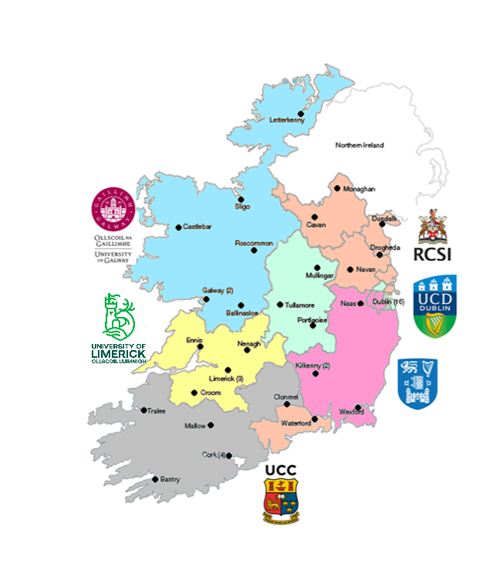
The Six Intern Training Networks:
Dublin/Mid-Leinster (DML)
Dublin/Northeast (DNE)
Dublin/Southeast (DSE)
West/Northwest (WNW)
Mid-West (MWT)
South (STH)

Intern Training Networks Sites
Note: This is the complete list of the clinical sites for the 2027-2028 Intern Training Year. The list is subjected to changes.
Intern Network/Medical School | Hospitals/Clinical Sites in Network
West North-West | Galway University Hospital
University of Galway (UG) | Portiuncula University Hospital
 | Letterkenny University Hospital
 | Roscommon University Hospital
 | Sligo University Hospital
 | Mayo University Hospital
 | Bon Secours Galway
 | Blackrock Clinic (Formerly Galway Clinic)
 | Our Lady's Hospital Manorhamilton
 | Arlington House Medical Centre, Oranmore
 | Sligo GP - GP Health Centre, Dromahair, Co. Leitrim
 | Claddagh Medical Centre, Galway GP
 | Scally McDaid Roarty Medical Practice, Letterkenny, GP
Dublin North-East | Connolly Hospital, Blanchardstown
Royal College of Surgeons in Ireland (RCSI) | University Hospital, Waterford
 | Our Lady of Lourdes Hospital, Drogheda
 | Beaumont Hospital
 | CHI - Temple Street
 | National Orthopaedic Hospital Cappagh
 | Cavan General Hospital
 | Mercers Medical Centre
 | Edenpark Medical, Tonlegee Primary Care Centre
 | Beaumont Park Clinic
Dublin Mid-Leinster | Mater Misericordiae University Hospital
University College Dublin (UCD) | Midland Regional Hospital, Tullamore
 | Midland Regional Hospital, Portlaoise
 | Regional Hospital Mullingar
 | National Orthopaedic Hospital Cappagh
 | Coombe Primary Care
 | Beacon Hospital
 | St. Columcille's Hospital
 | Mater Private Hospital, Dublin
 | St. Vincent's University Hospital
 | St. Michael's Hospital
 | Greystones Harbour Family Practice
 | CHI - Temple Street
 | The Brophy Family Practice, Navan Road
 | Tully Family Practice
Intern Network/Medical School | Hospitals/Clinical Sites in Network
Dublin South-East | Naas General Hospital
Trinity College Dublin (TCD) | Linn Dara CAMHS
 | St. James's Hospital
 | St. Luke's General Hospital, Kilkenny
 | Tallaght University Hospital
 | Wexford General Hospital
 | Rialto Medical Centre
 | Sundrive Medical Centre
 | Aylesbury Clinic
 | GPs at Tallaght Cross
South | Mercy University Hospital
University College Cork (UCC) | South Infirmary Victoria University Hospital
 | Bon Secours Hospital, Cork
 | Cork University Hospital
 | Bantry General Hospital
 | Mallow General Hospital
 | University Hospital Kerry
 | Tipperary University Hospital
 | St. Stephen's Hospital, Glanmire
 | Red House Family Practice, Mallow Primary Healthcare Centre
 | GP Cork (to be confirmed)
 | Ross Medical Centre, Killarney, Co. Kerry
 | Imokilly Medical Centre, Midleton
 | Broad Lane Family Practice, Blackpool, Cork
Mid-West | University Hospital Limerick
University of Limerick (UL) | University Maternity Hospital, Limerick
 | St. John's Hospital Limerick
 | Nenagh University Hospital
 | Primary Care, Ennis Medical
 | Mungret Medical Centre

Intern Training Programme
The National Intern Training Programme (NITP) for Education and Training in the Intern Year is designed to be a challenging and rewarding year. It is providing graduates with a supervised and supportive learning environment that will provide them with the basis for future practice as a doctor in their chosen field.
Online learning modules have been developed, which complement the on-site training provided to interns in hospitals and general practices. A range of modules will be available for interns commencing in July 2027.

All Intern Training Networks must provide clinical skills training, life support training and formal educational events.
Intern training provided must be in line with the NITP, although the precise content of the educational elements will vary across individual networks. Examples of training that may be provided include grand rounds, journal clubs, multidisciplinary case presentations, and “Human Factors” training and specialty/topic-specific study days.
The HSE has formal Service Level Agreements in place with the Universities/Medical Schools for the provision of intern training.
Each intern will be required to sign a Training Agreement, which sets out the training that will be provided to the intern by their Network and the intern’s responsibilities, such as minimum attendance rates.

Intern Training Posts
Details of intern posts available in July 2027 will be provided to applicants who are deemed eligible after Stage 1 of the application process. The total number of posts available nationally, currently stands at 915, including 48 Academic Track posts.

Academic Track for Internship
In parallel to the clinical internship posts, for the 2027 Intern intake, an academic internship will be available. The academic internship provides an opportunity for doctors at the beginning of their careers to continue, or to develop de novo, research, teaching and leadership/management skills in addition to the competencies outlined as part of the National Intern Training Programme.
Academic track interns will undertake one full rotation (3 months) in an academic internship post and then complete their other clinical rotations as normal. Further details can be found at Appendix 8.

Induction
All incoming interns are required to complete a mandatory induction course and a mandatory Overlap/Shadowing week prior to commencement of employment. The induction course will ordinarily take place at the location of the intern’s first training module or another specified site within the Intern Training Network. July 2019 saw the introduction of a standardised paid induction programme for interns in all networks. This takes place before work commences at clinical sites. Following assignment to a post, successful applicants will be notified of the time and location of the induction course.
Those interns on the academic internship programme are also expected to attend the mandatory induction provided by their clinical site.

Employment Contract
Interns will receive the Contract of Employment for Non-Consultant Hospital Doctors. The contract will be provided by the employing authority after the applicant has successfully been allocated to an intern post and received an offer of employment from the employing authority, subject to relevant satisfactory clearances.
The required clearances will be notified to the successful applicant by the employing authority when the offer of employment is made. In some cases, where an individual intern is employed by more than one employing authority (e.g., a voluntary hospital and a HSE hospital), separate contracts may be issued.
The total duration of internships commencing in July 2027 will be 12 months. Interns should return their signed contract to their employer. The NCHD contract can be seen at Medical Internship - HSE Career Hub

Progression through Training & Sign-Off
The Intern Training Programme for posts commencing July 2027 is for a defined period of 12 months and interns will be employed in each training rotation for a finite period. Interns are expected to complete their training within this period. The Intern Training Network is required to ensure that all interns under their remit are progressing in a manner which ensures patient safety and may assign remedial action on an individual basis.
If the Intern Training Network considers that an intern’s progress in the programme is unsatisfactory, the intern may be required to undertake additional training or assessment.

Failure to meet these additional requirements may result in removal from the Intern training programme and/or employment.
Where remedial training is required, the Intern Training Network will inform the employer and/or the HSE and/or the Medical Council of any concerns regarding the intern’s continued practice. Additional training will usually be required to be undertaken within the period of the rotation or a subsequent scheduled rotation.
If a recommendation for additional training remains upon completion of the 12-month period, this will be facilitated. Such matters will be handled on a case-by-case basis and are subject to agreement from the Employer.
Applicants should consult the NCHD Contract, at Medical Internship - HSE Career Hub for more information on employment matters.
In such circumstances, interns may be assigned to a different training site and/or different specialty areas. The usual contractual arrangements will apply in relation to employment matters.
The Medical Council (of Ireland) is statutorily responsible for granting Certificates of Experience to medical practitioners who have successfully completed a period of internship. Information on the criteria and process for the sign-off of the intern year Certificate of Experience are available from the Medical Council at www.medicalcouncil.ie.

